PRESS RELEASE
UNDER EMBARGO UNTIL FRIDAY, 21 SEPTEMBER 2018, 6:00 AM
WORK FOR NAMIBIAN CONTRACTORS- PIE IN THE SKY?
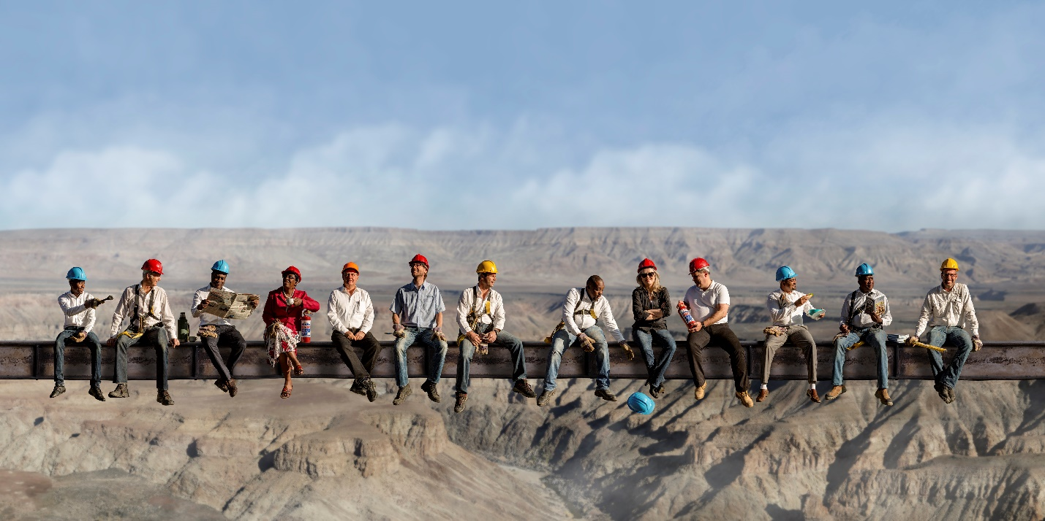
2017/2018 Members of the CIF Executive Committee

The Construction Industries Federation of Namibia (CIF) launched its fifth edition of its Annual CIF Directory this week to facilitate access to information about the organisation’s respective members and the services they provide. This is to ensure that, if in doubt, all buyers of construction services, especially all Namibian government authorities, are aware of the extent of capacities of the Namibian construction industry. The launch of the directory comes at a time when the Namibian industry is vying for business and continues to compete with foreign contractors.
Austerity measures to curb public spending, meant that many businesses in the Namibian construction sector have either downsized drastically or closed down, or indeed filed for bankruptcy. Consequently, many jobs were lost in the industry, and layoffs continue unabated until such time when the industry stabilises.
As spending cuts had slowed down the economy, the Namibian government embarked on securing financing from multi-lateral institutions such as the African Development Bank as well as from the Republic of China, as a result of bilateral negotiations, which principally should lead to opportunity for the 301 members listed in the CIF Annual Directory and ensure the revival of the construction sector.
However, if procurement and tender requirements remain as they are now, it is highly unlikely that the approved loan from the African Development Bank, as well as the proposed grants and loans from China to largely finance infrastructure developments with the intention to stimulate the economy, can achieve that optimally.
On the contrary, as it stands now, it appears that the local industry is being technically excluded from lucrative tenders. The tender requirements (historical financial performance and financial resources, average annual construction turnover) are of such a nature that they automatically preclude all Namibian contractors.
This becomes very apparent in the recent African Development Bank/Roads Authority Invitation for Prequalification (No. RA/DC-CR/06-2014/2A) for the Construction of Trunk Road 9/1 from Windhoek to Hosea Kutako International Airport to Dual-Carriage Freeway Standards: Phase 2A – Sam Nujoma Interchange to Dordabis Interchange (19.5km) that was issued on 3 September 2018.

Similarly, the recent Ministry of Works and Transport Invitation for Prequalification (No. MWT-DRIM/2018-03, ICB No. MWT-DRIMTIIP2018/A1.2) for the Construction of Earthworks, Structures and Plate Laying for the Upgrade of the Railway Line between Walvis Bay and Kranzberg Railway that was issued on 29 August 2018.

The same applies to the financing arrangements with the Republic of China. The industry is concerned that once again the conditions of grants and loans are of such a nature that it precludes the local industry due to stipulations determined by the Chinese government.

It begs the question of whether the approach of technically excluding Namibian contractors, is aligned with Namibia’s national development plans and if indeed it is in the interest of addressing unemployment and tackling poverty in Namibia. It is unlikely to lead to Namibia’s sustainable economic development.
Bärbel Kirchner, consulting general manager of the CIF comments: “Government might have secured favourable financial arrangements with China, however, the question is, what are the trade-offs? We should consider the overall costs involved – the loss of Namibia’s own capacity, further retrenchments, even the potential collapse of our entire industry. It is generally known that labour, products, and services are being imported. Cash is taken out of the country. We also need to better understand the arrangements with regard to taxation and contributions to our Receiver of Revenue.

“Government must be aware of the opportunity costs, and also stop working in silos. How can we hope to achieve tackling poverty and create jobs, and then come up with such deals that exclude our industry, which not only would have created employment opportunities, but also would have stimulated other sectors of our economy?

To avoid the tragedy of even more closures, the CIF demands that the tender for pre-qualification will be retracted immediately, and that the authorities engage the Namibian construction industry and revisit the tendering requirements.

Kirchner says: “Frankly, considering the current situation of our industry and the economy at large, we need to recognise the opportunity and collaborate to find the best solution for all. Our industry must be engaged in such multilateral and bilateral negotiations”.

